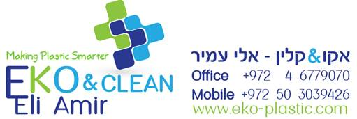

**EKO GGX NEW**

**Product Description**

*EKO GGX NEW is very effective purging agent, Non-Corrosive, Non-Abrasive and Non-Toxic designed to clean a variety of resins being processed concurrently, a situation that may occur in multi-layer, multi-resin sheet and film extrusion lines. Great for PE film and any other material within working temperatures of 120°C –280°C.*

**Product information**

|  |  |  |  |
| --- | --- | --- | --- |
| PHYSICAL | Unit | Test Method | Property Value |
| Density | g/cm³ | ISO 1183 | 1.1 |

Date: 25.09.17

Version: A

The information contained in this document supplied in good faith. However it is given purely as an indication. It shall not be construed in any way as formal commitment or warranty on our part. Notably in respect of the eventual infringement of any rights of third parties who may use our products.

We remain at your entire disposal to provide you with any information that you might require.