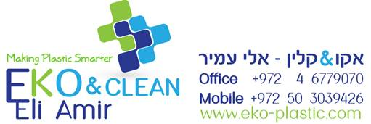

EKO CLEAR NEW

**Product Description**

EKO CLEAR NEW is very effective purging agent specialized in clear materials. Non-Corrosive, Non-Abrasive and Non-Toxic designed to clean transparent materials with working temperatures 280°C – 320°C. Clear PC, PP, PE, Acrylic, Clear PS

**Product information**

|  |  |  |  |
| --- | --- | --- | --- |
| PHYSICAL | Unit | Test Method | Property Value |
| Filler content | % | ISO 3451-1 | 10 |
| Bulk Density | Kg/Lit | INTERNAL | 1.27 |
| Moisture Content | ppm | INTERNAL | <1500 |

Date: 24.09.17

Version: A

The information contained in this document supplied in good faith. However it is given purely as an indication. It shall not be construed in any way as formal commitment or warranty on our part. Notably in respect of the eventual infringement of any rights of third parties who may use our products.

We remain at your entire disposal to provide you with any information that you might require.